
School of Computer Science & Engineering

5COSC020W DATABASE SYSTEMS COURSEWORK (2024/2025)
Module Leader | Dr Francois ROUBERT
Unit | Database Systems Coursework – INDIVIDUAL COURSEWORK
Student Name | Abdullah
Student ID | W20271086
Student Email | w2027108@westminster.ac.uk
Group Number | 5CS13
Day Of the Week | Tuesday
Time Of the Tutorial | 4:00pm to 6:00pm
Tutor | Stephen Sean Roberts

Coursework Part A: Conceptual EERD [50 Marks]

You have been hired as a Database Architect to undertake a database design project for a scheme called Racketminster.

Your job in part A is to investigate the Racketminster Project, produce a high-quality CONCEPTUAL ENHANCED ENTITY RELATIONSHIP DIAGRAM (EERD) as a conceptual database design to support the data needs of the Racketminster scheme, and document your design with an accurate Data Dictionary.

For this, you have been given a Racketminster Project Pack containing two key documents (Documents A.1 and A.2.) and one digital resource (Resource A.3.).

Racketminster Project Pack Document A.1. – The Project Brief
Author: Francois Roubert & Chathura Sooriya-Arachchi, Board of Managing Directors for Racketminster
Ovestminster is a small town in the southeast of England, United Kingdom, well-known for its leafy green spaces and great enthusiasm for outdoor life. In particular, the town runs a popular sporting scheme called Racketminster to allow players to participate in racket-based sports, like tennis and pickleball.

To run Racketminster, the town has several lush parks which contain dedicated courts for racket sports. To ensure that they are always kept in pristine condition, the town parks are continuously looked after by specifically allocated Racketminster caretakers who are responsible for their preservation. There are different kinds of courts in these parks, for people to play tennis or pickleball. Some courts are specific for tennis; others are specific for pickleball, and some can be used for both. Each court comes with its own equipment allocated to it (typically fixed or movable items, like nets, rackets, balls, etc.). A careful record of all the pieces of equipment assigned to each court needs to be kept.

As for parks, courts are also regularly maintained by specifically dedicated and highly trained Racketminster caretakers to ensure they are constantly kept in full running order and that the equipment they offer is always top quality. While not required for parks (as they are continually looked after), the maintenance of courts needs to be recorded separately (date, time, maintenance status and maintenance log) so that a clear up-to-date maintenance record is kept for each court, for greater transparency and accountability. Likewise, it is essential to hold accurate maintenance records for pieces of equipment to make sure timely information is captured about their regular upkeep.

Racketminster playing sessions are pre-scheduled to run on specific courts. Some sessions are specifically allocated as unsupervised sessions to allow players to play completely on their own initiative, typically as two players (singles) or four players (doubles). Other playing sessions are scheduled as supervised, as they run under the guidance of qualified instructors. Supervised sessions can be personal training sessions (one-to-one sessions with an instructor) or supervised group sessions (multiple players, up to two instructors). Supervised group sessions can come under three categories: fitness-play sessions (players get to both exercise and learn how to play), group coaching sessions (more structured learning lessons at different levels) or social-fun sessions (players gets to socialise and play racket sports in a more relaxed environment, still with an instructor overseeing the session).

For players to play as part of the Racketminster scheme, they need to place a booking for a specific session, depending on what type of sessions they are interested in. A booking tends to be usually for a single session. However, players can block-book unsupervised sessions if they want to book more sessions ahead of time. In this case it is essential to keep track of how each unsupervised session follows on from a previous unsupervised session for traceability.

Also, a player has the possibility to recommend the Racketminster scheme to other players. If they do, it is important to capture which players recommends Racketminster to which other players, so that in the future a discount-based incentive system can be introduced.

Racketminster Project Pack Document A.2.: AI-Generated Draft Conceptual EERD
Author: ChatGPT 4o
Source: The Racketminster Project Brief presented in Document A.1.
Prompt 1: Please produce a high-quality CONCEPTUAL ENHANCED ENTITY RELATIONSHIP DIAGRAM (EERD) to support the data needs of the Racketminster scheme.
Result 1: Generated text describing different components of the EERD.
Prompt 2: Can you please create the actual diagram?
Result 2:
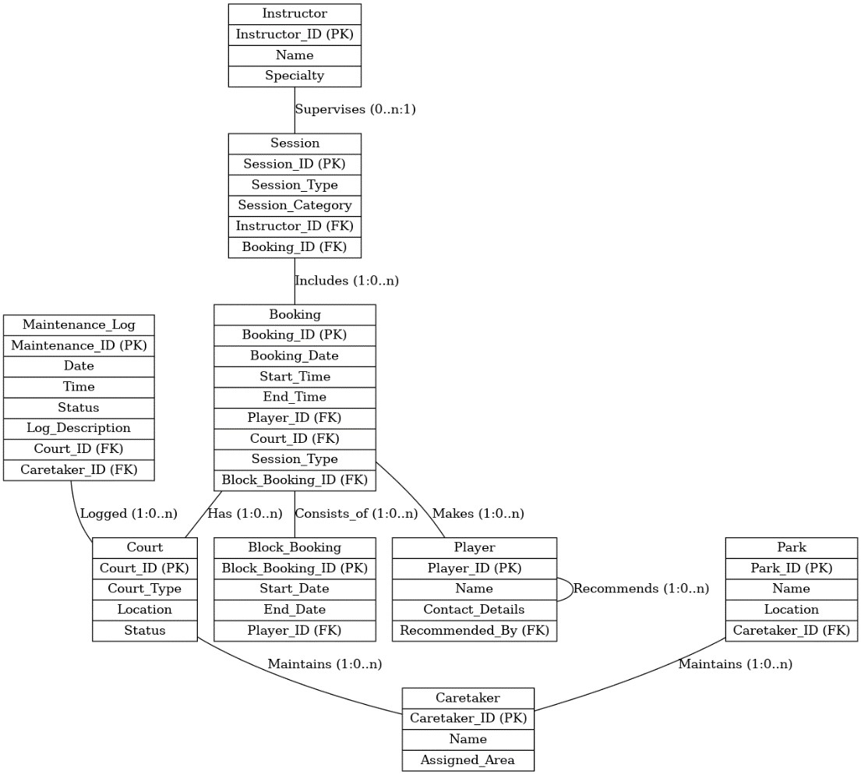

Racketminster Project Pack Resource A.3.: Questions & Answers Forum (Q&A Forum) on Blackboard
https://learning.westminster.ac.uk/ultra/courses/_97943_1/outline/discussion/_5316624_1?view=discussions&courseId=_97943_1
Deadline to post Business Questions: Thursday 17 October 2024 at 17:00:00
You can use this online Q&A forum to ask key Business Questions (BQs) for the Racketminster’s Board of Directors to clarify your understanding of the scheme, its data needs and the components of the conceptual EERD you are building.

Your BQs must be asked on the forum only. BQs asked by email will be ignored.

Your BQs must be formulated in a way that is understandable to Racketminster Managing Directors who do not have technical knowledge in the field of database systems. Questions directed at lecturers will not be accepted.
Your BQs must be totally unique and formulated by you, and only you, and not be AI generated.

Your BQs must be asked by the deadline specified above (17/10/24). Any questions asked after the deadline will not be considered.

A selection of the most relevant and useful BQs will be answered shortly after the deadline (17/10/24), by the Managing Directors. You are strongly encouraged to use the answers to improve and refine your conceptual EERD.

Coursework Part A Questions

You are required to attempt the following questions for part A.

QUESTION 1: CRITICAL EVALUATION & REFLECTIVE COMMENTARY

The provided Document A.2 Enhanced Entity-Relationship Diagram (EERD) has several issues that limit its effectiveness. here are the explanation of the issues and how I can improve this model.

Ambiguous Relationships
In that AI generated Document A.2. diagram, there is a lack of clear labels and relationships. For example, “relationship (1.0..n)” between Player and Booking is vague; it doesn’t clearly show whether a player can have multiple bookings or just one.

Inconsistent Multiplicities
The municipalities that are used in that diagram do not reflect the real-world constraints. For example, Instructor to Session is “Supervises (0..n),” which suggests an instructor might not supervise any sessions. This is not align with real scenarios where sessions require instructors.

Unclear Attribute Placement:
As for Attributes like Start_Time and End_Time in Booking seem better suited for Session, as session times are inherent to sessions rather than bookings.

Lack of Specialization:
It seems like AI is unable to generate specialization for these relationships like group coaching session and personal training session. Which could lead to redundancy and limits to capture specific attributes for each session type.

Poor Key Management:
Primary and foreign keys are not well present . Relationships like Instructor_ID in Session lack proper multiplicity rules, leaving it unclear if each session must have an instructor.

The Enhanced Entity-Relationship Diagram (EERD) that I created Is well organized where I mainly focused on clarity, simplicity, and alignment with real-world processes.

Define Clear Entities and Relationships:
Prefix names to w2027108_Player, w2027108_Instructor, w2027108_Session, w2027108_Booking, etc., and label relationships clearly. Each relationship is very straightforward and clear.

Use Specialization and for Sessions and Bookings
Introduce specializations between different kind of sessions, use recursive relationship to present how one player can recommend another player, use Tenary relationship between w2027108_caretaker, w2027108_Court and w2027108_ park to make the EERD diagram a better fit for the systems requirement.

QUESTION 2: ENTITIES (04 Marks)

Create an Entity Data Dictionary Table to document the identified entities for Racketminster.
To produce this supporting documentation, fill in the table below to briefly explain each entity.

Entity name | Brief Explanation
w2027108_Player | This entity represents Players who participates on Racket minster project
w2027108_Booking | This entity represents booking reservation made by players.
w2027108_Block_booking | A block booking is when a player reserves multiple sessions or activities at once, usually for a set period
w2027108_session | This entity represents any organized activity or event on a time set.
w2027108_supervised session | This entity represents a session which is guide under qualified instructor.
w2027108_unsupervised session | This entity represents session which allow players to play completely on their own capability. it can be within two players or four players.
w2027108_supervised  Personal trainning session | This entity represents one-on-one training session with a coach or trainer to help the player improve their fitness or skills.
w2027108_supervised group session | This entity represents a session where a group of players work out or practice together under the guidance of a trainer or coach.
w2027108_fitness-play session | This entity represents the session where player get the chance exercise and get knowledge of game.
w2027108_group coaching session | A more structured learning session where a group of players receive coaching or training together, focusing on improving their skills in a particular sport or activity.
w2027108_social fun session | This is a more relaxing environment session where players get to socialize and play racket sports. This session is also overseeing by instructor.
w2027108_Court | This entity represents a physical area or space where Racketminster sports activities take place, such as tennis or pickleball.
w2027108_Equipment | This entity is for the playing equipment’s (Fixed or movable items like nets, racket balls, light etc.)
w2027108_Maintanence record | This entity is for keeping record that track of repairs, servicing, and upkeep of equipment of courts to ensure everything is in good condition.
w2027108_Park | This entity represents lush parks in Over minster where multiple courts are available for Racket minster Scheme.
w2027108_caretaker | This entity represents the person who are specially dedicated and highly trained caretakers who are responsible for looking after the park, courts of Racketminster.

QUESTION 3: SPECIALISATIONS

Create a Specialisation Data Dictionary Table to document the identified specialisations for Racketminster. To produce this supporting documentation, fill in the table below to briefly explain each specialisation.

General entity | Specialised entity | Brief explanation
w2027108_session | w2027108_supervised session
w2027108_session | w2027108_unsupervised session
w2027108_supervised session | w2027108_supervised  Personal trainning session
w2027108_supervised session | w2027108_supervised group session
w2027108_supervised group session | w2027108_fitness-play session
w2027108_supervised group session | w2027108_group coaching session
w2027108_supervised group session | w2027108_social fun session
w2027108_supervised group session | W2027108_Recommended Player
w2027108_supervised group session | W2027108_Recommended Player
W2027108_caretakerManages_alloc | w2027108_caretaker
W2027108_caretakerManages_alloc | w2027108_Park
W2027108_caretakerManages_alloc | w2027108_Court

QUESTION 4: RELATIONSHIPS & MULTIPLICITIES (14 Marks)

Create a Relationships & Multiplicities Data Dictionary Table to document the identified relationships and associated multiplicities (participations + cardinalities) for Racketminster.
To produce this supporting documentation, fill in the table below to briefly explain the relationships and associated multiplicities.

Entity name | Multiplicity | Relationship | Multiplicity | Entity name | Brief justifications for the multiplicity (4 statements for each relationship)
w2027108_Recommander | 0..1 | recommends | 0.. * | w2027108_Recommanded Player
w2027108_Player | 0..1 | makes | 0..1 | w2027108_Booking
w2027108_Booking | 1..1 | for | 1..1 | w2027108_session
w2027108_session | 0..1 | Take place | 1..1 | w2027108_Court
w2027108_Court | 0..1 | Assigned to | 0..1 | w2027108_Equipment
w2027108_Equipment | 1..1 | Keeps record | 0..1 | w2027108_Maintanence Log
w2027108_Maintanence Log | 0.. * | Keeps record | 0.. * | w2027108_Court
w2027108_Court | 1.. * | offers | 1.. * | W2027108_  sportType
w2027108_caretaker | 1..1 | Can be | 1..1 | w2027108_stuff
w2027108  _Instructor | 1..1 | leads | 0..1 | w2027108_supervised session
w2027108_Player | 1..1 | make | 0..1 | w2027108_Block_booking
w2027108_Block_booking | 0..1 | for | 0..* | w2027108_unsupervised  session

QUESTION 5: ATTRIBUTES & PRIMARY KEYS (5 Marks)

Create an Attributes and Primary Key Data Dictionary Table to document the identified attributes and primary keys for Racketminster.
To produce this supporting documentation, fill in the table below to briefly explain the attributes and primary keys identified for each entity.

Entity name | Attributes for each entity (include PK) | Brief explanation
w2027108_Player
w2027108_Booking
w2027108_Block_booking
w2027108_session
w2027108_Court
w2027108_Equipment
w2027108_Maintanence Log
w2027108_caretaker
w2027108_Park
w2027108_Court
W2027108_
sportType

w2027108_stuff
w2027108
_Instructor

w2027108_caretaker
w2027108_session
w2027108_supervised session
w2027108_unsupervised session
w2027108_supervised
Personal trainning session
w2027108_supervised group session
w2027108_fitness-play session
w2027108_group coaching session
w2027108_social fun session

For more information, please refer to page 516 of the 6th edition of the Connolly’s textbook.

QUESTION 6: CONCEPTUAL EERD QUALITY & NOTATIONS (5 Marks)

Produce a complete high-quality CONCEPTUAL EERD for Racketminster. This CONCEPTUAL EERD needs to include all the identified entities, specialisations, relationships, multiplicities, attributes, and primary keys.

- It should fit on one page of the report and be easy to read.
- It should use UML notations only, as learnt in this module, and no other notations.
- The use of non-UML notations will be penalised, and marks will be deducted.
- The names of all entities & attributes should be prefixed with the student id number starting with w.
- The diagram is ultimately what is being assessed. The absence of a diagram will lead to zero marks.

Coursework Part A Marks Allocation

Part A will be assessed based on the following marking criteria:

Marking Criteria | Marks
Relevance of the critical evaluation and usefulness of the reflective commentary | 10
Correct identification of entities | 04
Correct identification of specialisations | 12
Correct identification of relationships & multiplicities | 14
Correct identification of attributes & primary keys | 05
High quality of representation of the conceptual EERD and correct use of UML notations | 05
PART A TOTAL | 50

Coursework Part B: Logical ERD [50 Marks]

You have been hired as a Database Architect to undertake a database design project for a firm called AudioVizzion.

Your job in part B is to map a given Conceptual Enhanced Entity Relationship Diagram (EERD) onto a high-quality LOGICAL ENTITY RELATIONSHIP DIAGRAM (ERD) as a logical database design to represent how the business data for AudioVizzion can be organised as a set of interrelated tables that could then be implemented with a Relational Database Management System (RDBMS).

For this, you have been given a AudioVizzion Project Pack containing two key documents (Documents B.1 and B.2.).

AudioVizzion Project Pack Document B.1. – Simple Project Brief
Author: Francois Roubert & Chathura Sooriya-Arachchi, Board of Managing Directors for AudioVizzion
AudioVizzion is a large retail chain that offers optical and audiology services, and essentially sells spectacles and hearing aids to the public. AudioVizzion operates globally from several branches located all around the United Kingdom. Every branch offers AudioVizzion customers the opportunity to get tested on their vision and/or on their hearing before being able to purchase what the company refers to as Visual Devices (i.e. frames and lenses for glasses) and/or Hearing Devices (i.e. hearing aids).

2024/25 - 5COSC020W Coursework Specs Author: F. Roubert | Moderator: C. Sooriya-Arachchi

AudioVizzion Project Pack Document B.2. – Conceptual Enhanced Entity Relationship Diagram
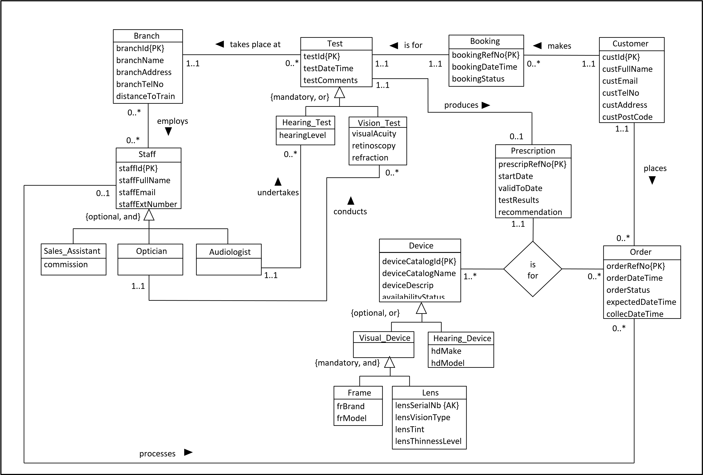
8

2024/25 - 5COSC020W Coursework Specs Author: F. Roubert | Moderator: C. Sooriya-Arachchi

Coursework Part B Questions

You are asked to attempt the following question for part B.

Prefix the names of all tables and attributes with your student id number starting with w (see end of doc).

QUESTION 7: MAPPING CONCEPTUAL EERD TO LOGICAL ERD (50 Marks)

Map the Conceptual EERD given in document B.2. to produce a complete LOGICAL ERD for AudioVizzion. This LOGICAL ERD needs to include all the correct tables, relationships, multiplicity constraints, attributes, primary keys and foreign keys. It should be easy to read and needs to fit on one page of the report.

- It should fit on one page of the report and be easy to read.
- It should use UML notations as learnt in this module and no other notations.
- The use of non-UML notations will be penalised, and marks will be deducted.
- The names of all tables & columns should be prefixed with the student id number starting with w.
- The diagram is ultimately what is being assessed. The absence of a diagram will lead to zero marks.

Part B Marks Allocation

Part B will be assessed based on the following marking criteria:

Marking Criteria | Marks
Clarity, formatting, and structure of the logical ERD with correct UML notations | 05
Correct mapping of specialisations | 24
Correct mapping of many-to-many relationships & ternary relationships | 10
Correct mapping of one-to-many relationships and one-to-one relationships (optional) | 07
Correct mapping of one-to-one relationships (mandatory) | 04
PART B TOTAL | 50

9

2024/25 - 5COSC020W Coursework Specs Author: F. Roubert | Moderator: C. Sooriya-Arachchi

KEY REQUIREMENTS FOR THE ENTIRE COURSEWORK

- Only UML notations are accepted for this coursework, as introduced in this module.

- You need to prefix all your entities, tables, and attributes with “w + the 7 digits of your ID number” as provided by the University, both for Part A (Racketminster Conceptual EERD) and Part B (AudioVizzion Logical ERD).

- Failure to use UML notations and to prefix entities, tables and attributes with an ID number will be penalised and marks will be deducted.

For example, if my name is Francois Roubert and my ID number is w1234567, when I identify the entity or table “Module” and its attributes “moduleCode”, “moduleName” and “moduleType”, I will have to represent it this way:
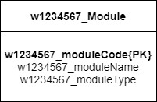

End of Document
10

